Name- Akash Bhardwaj

Reg No-11019210034

Class -B.Tech CSE-C (DSAI)

**Assignment-1**

**Quantifiers:**

Quantification is the way by which a Propositional function can be turns out to be a proposition. The expressions ‘for all’ and ‘there exists’ are called quantifiers. The process of applying quantifier to a variable is called quantification of variables.

There are two types of quantification-

****1. Universal Quantification-**** Mathematical statements sometimes assert that a property is true for all the values of a variable in a particular domain, called the **domain of discourse**. Such a statement is expressed using universal quantification.  
The universal quantification of Rendered by QuickLaTeX.com for a particular domain is the proposition that asserts that Rendered by QuickLaTeX.com is true for all values of Rendered by QuickLaTeX.com in this domain. The domain is very important here since it decides the possible values of Rendered by QuickLaTeX.com. The meaning of the universal quantification of Rendered by QuickLaTeX.com changes when the domain is changed. The domain must be specified when a universal quantification is used, as without it, it has no meaning.

Formally,

The universal quantification of Rendered by QuickLaTeX.com is the statement

"Rendered by QuickLaTeX.com for all values of Rendered by QuickLaTeX.com in the domain"

The notation Rendered by QuickLaTeX.com denotes the universal quantification of Rendered by QuickLaTeX.com.

Here Rendered by QuickLaTeX.com is called the universal quantifier.Rendered by QuickLaTeX.com is read as "for all Rendered by QuickLaTeX.com Rendered by QuickLaTeX.com".

* **Example 1:** Let Rendered by QuickLaTeX.com be the statement “Rendered by QuickLaTeX.com > Rendered by QuickLaTeX.com“. What is the truth value of the statement Rendered by QuickLaTeX.com?  
  **Solution:** As Rendered by QuickLaTeX.com is greater than Rendered by QuickLaTeX.com for any real number, so Rendered by QuickLaTeX.com for all Rendered by QuickLaTeX.com or Rendered by QuickLaTeX.com.

****2. Existential Quantification-**** Some mathematical statements assert that there is an element with a certain property. Such statements are expressed by existential quantification. Existential quantification can be used to form a proposition that is true if and only if Rendered by QuickLaTeX.com is true for at least one value of Rendered by QuickLaTeX.com in the domain.

Formally,

The Vexistential quantification of Rendered by QuickLaTeX.com is the statement

"There exists an element Rendered by QuickLaTeX.com in the domain such that Rendered by QuickLaTeX.com"

The notation Rendered by QuickLaTeX.com denotes the existential quantification of Rendered by QuickLaTeX.com.

Here Rendered by QuickLaTeX.com is called the existential quantifier. Rendered by QuickLaTeX.com is read as "There is atleast one such Rendered by QuickLaTeX.com such that Rendered by QuickLaTeX.com".

* **Example** : Let Rendered by QuickLaTeX.com be the statement “Rendered by QuickLaTeX.com > 5″. What is the truth value of the statement Rendered by QuickLaTeX.com ?  
  **Solution:**  Rendered by QuickLaTeX.com is true for all real numbers greater than 5 and false forcall real numbers less than 5. So Rendered by QuickLaTeX.com.

**Negation of Quantified statement :**

This is true for any proposition p(x).

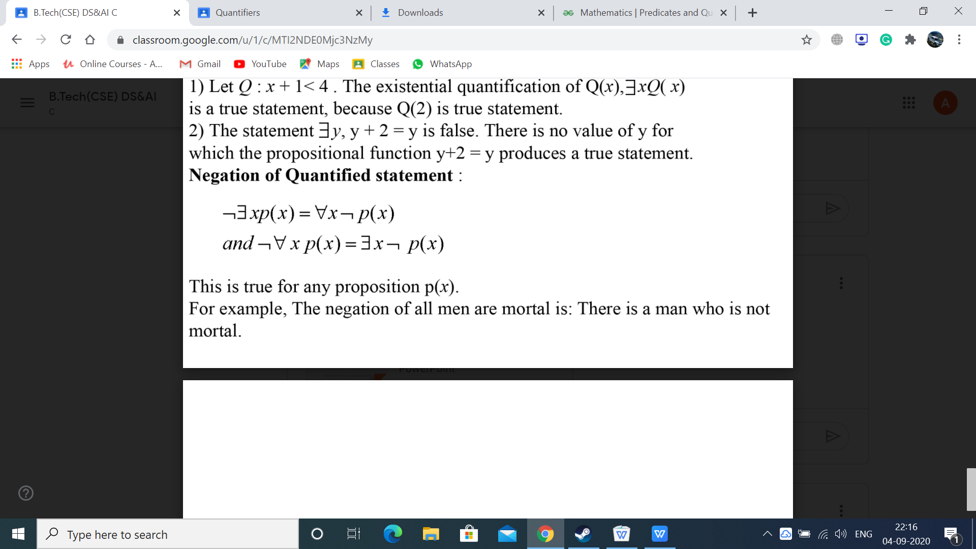

For example, The negation of all men are mortal is: There is a man who is not

mortal.